

**HOTEL RESERVATION SYSTEMS**

# USER MANUAL

**HOTEL RESERVATION ONLINE**

**M3CS2514B**

|  |  |
| --- | --- |
| **NAME** | **ID** |
| **AMIRAH ZULAIKHA BINTI AZHARI** | **2017381953** |
| **NURUL SYUHADA BINTI MASRI** | **2017330487** |
| **MUHAMMAD FARIS NIZAR BIN ZULKEFLI** | **2017322725** |
| **USAID BIN ZULKIFLI** | **2017511477** |

**Lecturer name:**

**MOHD ALI BIN MOHD ISA**

**Contents**

HOTEL RESERVATION SYSTEMS .............................................................. 2

HOME PAGE............................................................................................................................... 3

REGISTER PAGE....................................................................................................................... 6

LOGIN PAGE .............................................................................................................................. 8

BOOKING PAGE ...................................................................................................................... 12

## HOME PAGE

To open Hotel Reservation System homepage

* Open browser(**Chrome**) from your local computer
* Type in this URL localhost/project

1. Main page

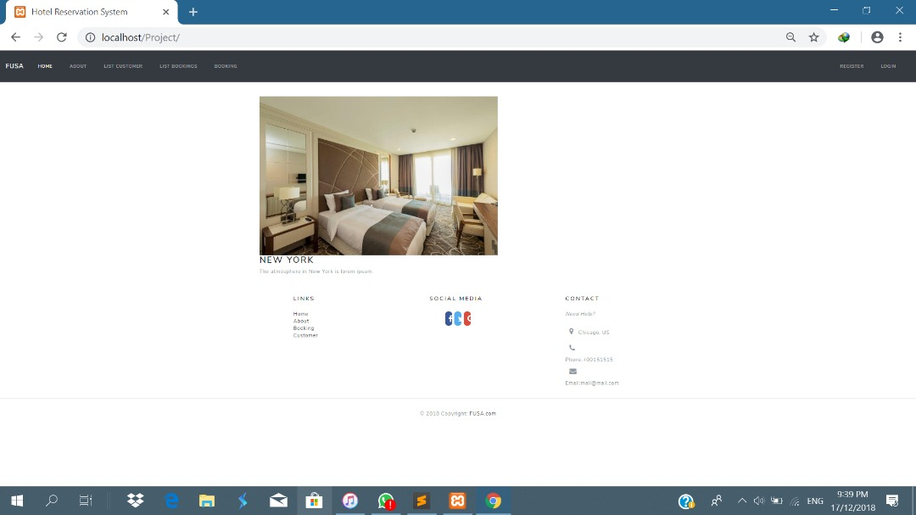

1. Register Form

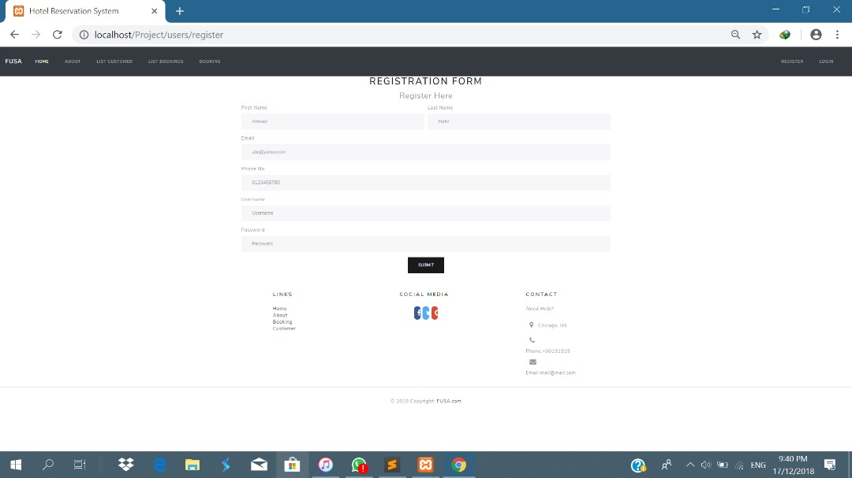

1. Login form

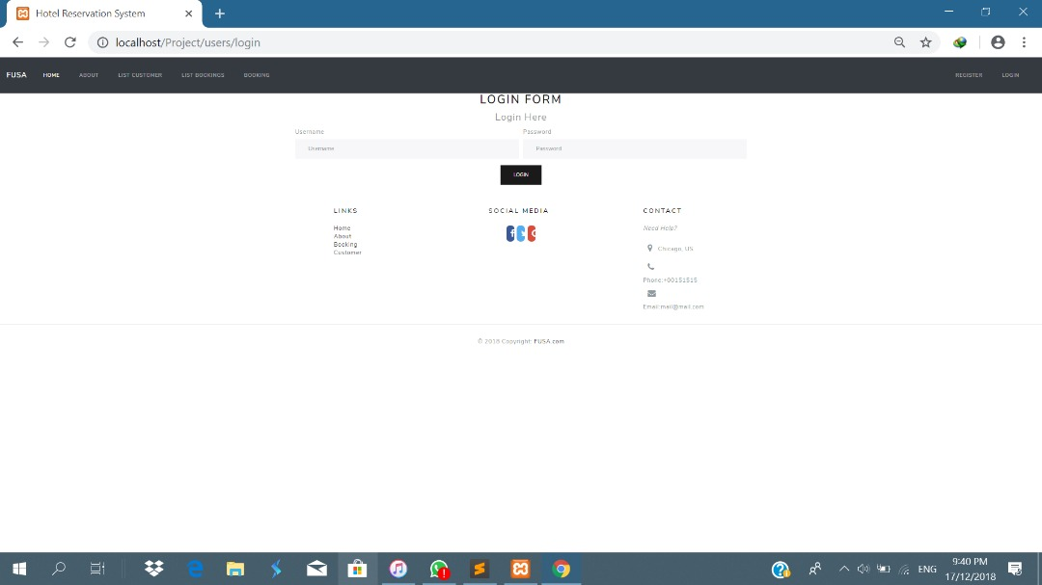

|  |  |
| --- | --- |
| Website Content | Descriptions |
| i. MAIN PAGE | The main page a users navigating to a website from a web search engine will see. |
| ii. REGISTER | It able to create users account for check their booking. |
| iii. LOGIN | Hotel Reservation System for staff login page. |

**USER**

## REGISTER PAGE

To start using Hotel Reservation Systems

### 2. 1 REGISTER USERS

* Open browser(IE, Chrome, Mozilla) from your local computer

|  |  |
| --- | --- |
| **Step** | **Description** |
| Step 1 | Click the “**Register**” |
| Step 2 | Key in all the user information to register as user. |
| Step 3 | Key in the password to login. |
| Step 4 | Click on “**Submit”**  button to save the data. |
| Step 5 | All the information will save into “**Users”** for every user that register. |

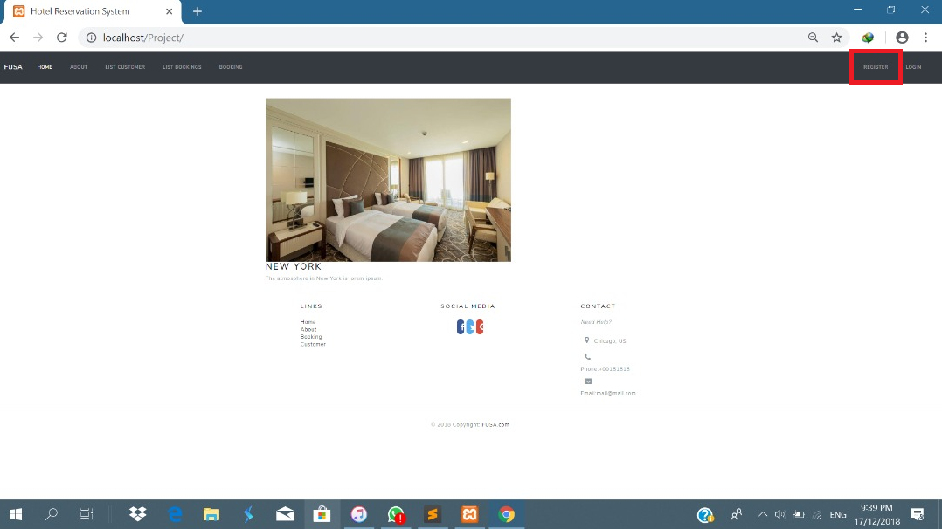

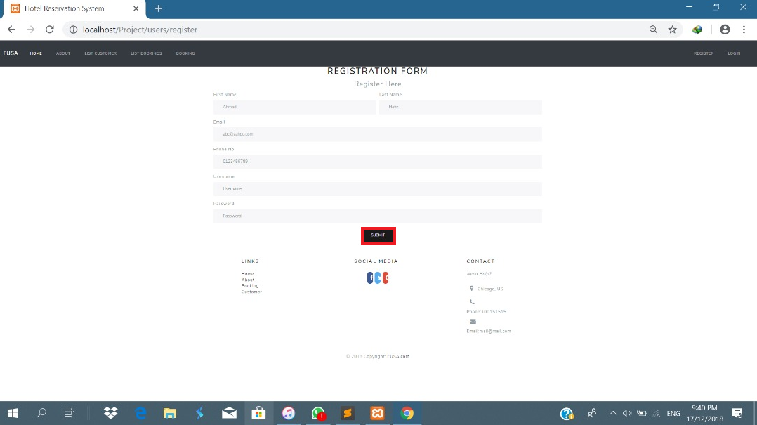

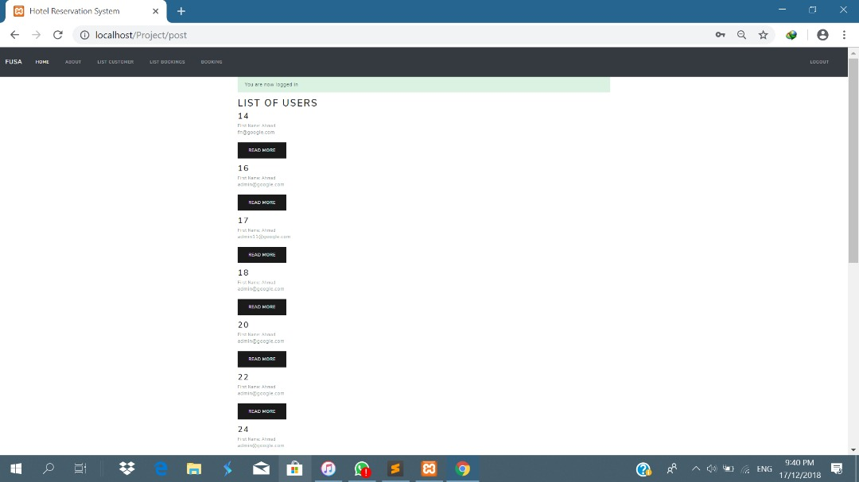

## LOGIN PAGE

### 2. 2 LOGIN PAGE

* Open browser(IE, Chrome, Mozilla) from your local computer
* To log in , type in this URL localhost/project then find at taskbar “**Login**”.
* Hotel Reservation System to login page will be displayed as below, key in your **USERNAME** and **PASSWORD.**

|  |  |
| --- | --- |
| **Step** | **Description** |
| Step 1 | Click the “**LOGIN**” |
| Step 2 | Key in “**USERNAME**” and “**PASSWORD**”. |
| Step 3 | Click on “**LOGIN”**  button to login as user. |



|  |  |
| --- | --- |
| Action | Descriptions |
| • NEW USERS | It is to create new users . |
| • USERS | List of information users and password with encyption. |
| • EDIT | It for update any information. |
| • DELETE | To delete all the user information. |
| • VIEW | It view full of users details. |

### LIST OF USERS

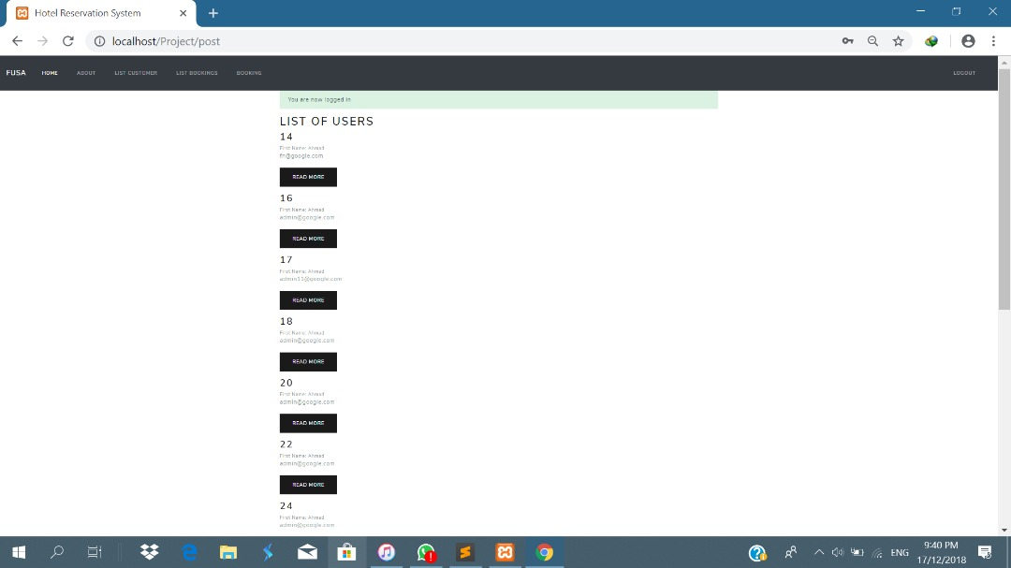

**b. DELETE ALL THE DETAILS**

**-It is for delete information about users.**

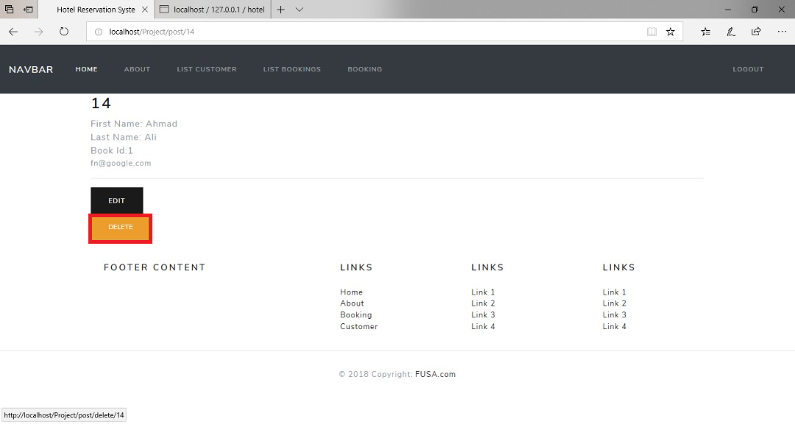

**d.** Edit information users

**-**“**Edit”** to update any information.

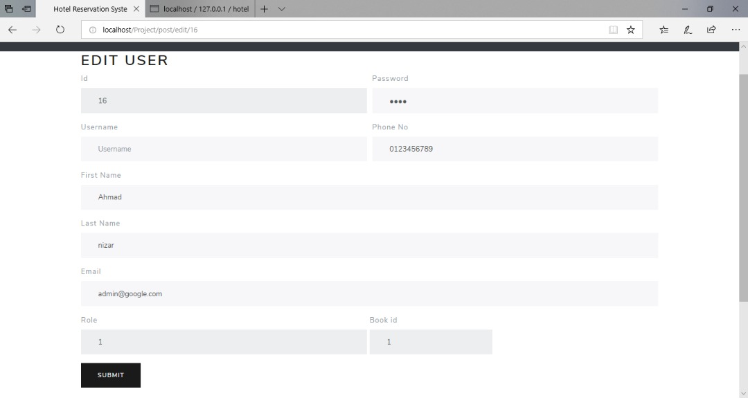

# USER FOR BOOKING

## BOOKING PAGE

It for booking in Hotel Reservation Systems

### 2. 3 BOOKING MANAGEMENT

* Open browser(IE, Chrome, Mozilla) from your local computer .
* Type “**localhost/Project”** to open our website

|  |  |
| --- | --- |
| **Step** | **Description** |
| Step 1 | Click the “**BOOKING**” |
| Step 2 | They show the insert for new booking and insert all the information. |
| Step 3 | Click the “**SUBMIT”** for confirmation booking. |

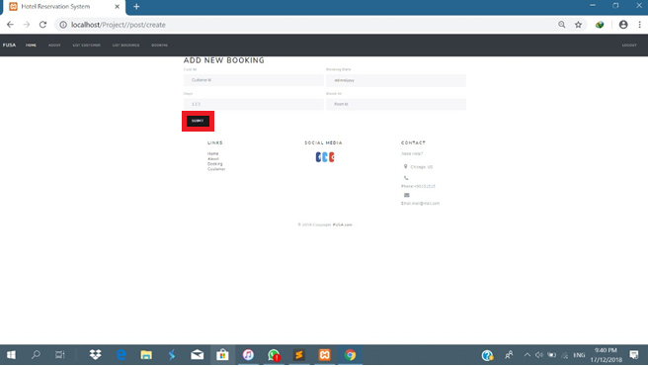

### a. LIST OF BOOKING

**i. List of infomation booking and can search the list for check the booking details.**

